The Oaks Community Garage Sale
March 10th & 11th 10:00 AM – 6:00 PM
Fundraiser for the children’s Easter Party on March 31st
5607 Jackson Valley Road
Ione, CA 95640

Open to the public to buy or sell!
$5 to rent a space in the clubhouse to sell your goods
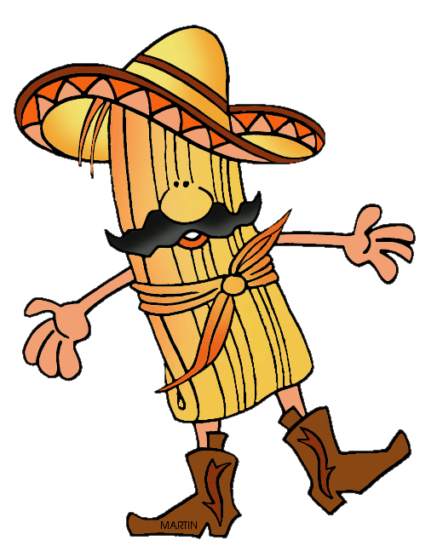
Free bounce house for the kids!!!
Hot Dogs $1.50
Homemade tamales $3
Fruit Punch $0.50
Assorted baked goods will also be sold

For details please call the social committee:
Patsy Johnson @ 274-4871 or Toni Gutherz @ 274-4873

