Don’t Flush Trouble
3
By: Terri Bailey
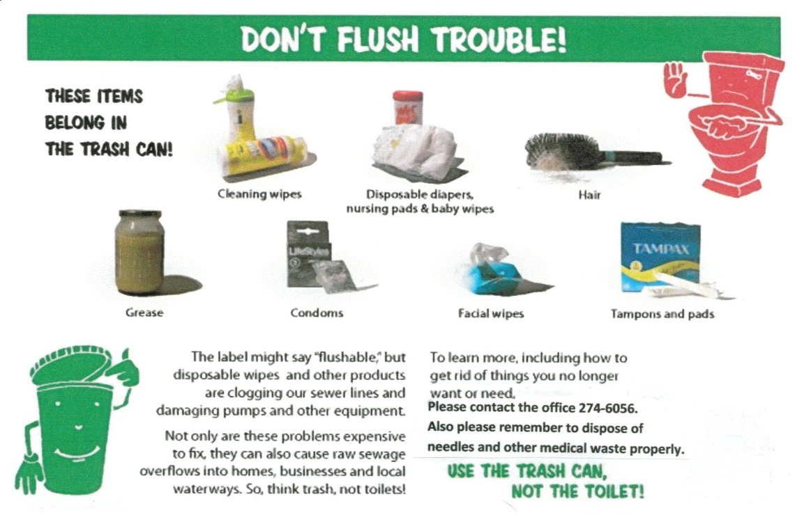

I know this issue is somewhat taboo and certainly not one which anyone likes to talk about, much less be lectured on. But, as a property owner here in the Oaks you are also the proud owner of a Waste Water Treatment Facility. As an owner you should be aware of the basic operation and maintenance of the facility and know what you can do as an owner to prolong the life of the facility and to ensure it operates in a safe and efficient manner.
Our system has a collection point, three lagoons and a spray field. This system is designed to allow waste to be broken down naturally under controlled conditions. The system includes physical and naturally occurring chemical processes which remove solids and heavier materials. What is left behind is the liquid that contains soluble and insoluble organic materials. There are no non-natural occurring chemicals used in the treatment process, we depend upon gravity to settle solids to the bottom of the lagoon where they are then broken down through the natural biological treatment of organic material.
As you can see the system was designed for disposal of organic material. The system operator has expressed concerns regarding items that are being sent through the system. We are asking that you refrain from flushing items that will damage the system or cause harm to the operator.
I would also ask all of you who have medical waste, especially needles, to please dispose of them properly. If you flush medical waste you are endangering our employees and sending hazardous material into the system which could cause expensive repairs, and must be removed from pipes and lagoons.
I found the above post card online and received permission from King County Washington to re-print it in our newsletter. Thank you in advance for your efforts in helping with this issue. Please let me know if you have any questions.

